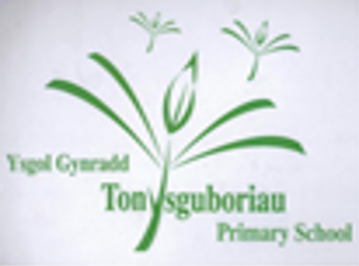
Tonysguboriau Primary School

Mathematics Calculation Policy

‘The development of mathematics has always gone hand in hand with the development of civilisation itself. A truly international discipline, it surrounds us and underpins so many aspects of our daily lives, such as architecture, art, music, money and engineering. It is creative and beautiful, both in its own right and in its applications, Mathematics and numeracy can help learners become ethical, informed citizens of Wales and the world by providing them with tools to analyse data critically, enabling them to develop informed views on social, political, economic and environmental issues. It encourages clarity of thinking, allowing learners to understand and make reasoned decisions.’ Curriculum for Wales 2020

INTRODUCTION

This Calculation Policy has been produced to ensure consistency and progression in teaching throughout the school that is age appropriate. It aims to introduce children to the processes of calculation through concrete, pictorial and abstract activities. As children begin to understand the underlying ideas, they develop ways of recording to support their thinking and calculation methods, use particular methods that apply to special cases and learn to interpret and use the signs and symbols involved. This policy shows the natural progression that a child should make in their mathematical education. Children should not progress onto the advanced stages of formal written methods until they have a secure conceptual understanding.

Intent
Maths is a journey and long-term goal, achieved through exploration, clarification, practice and application over time. At each stage of learning, children should be able to demonstrate a deep, conceptual understanding of the topic and be able to build on this over time.

Our overall aims for when children leave Tonysguboriau Primary School, are:
- develop a positive attitude to mathematics as a subject in which all children gain success and pleasure.
- have access to a high quality maths curriculum that is both challenging and enjoyable, and builds upon previous learning.
- be provided with a variety of mathematical opportunities, which will enable them to make relevant connections.
- ensuring children are confident mathematicians who are not afraid to take risks.
- develop an ability to express themselves fluently, to talk about the subject with assurance, using correct mathematical language and vocabulary.
- develop mathematical skills and knowledge and recall of basic number facts and the four operations
- be able to use this knowledge and understanding to carry out calculations mentally
- make use of pictorial representations and informal notes to help record steps and part answers when using mental methods that generate more information than can be kept in their heads
- have an efficient, reliable, compact written method of calculation for each operation that children can apply with confidence when undertaking calculations that they cannot carry out mentally. They will do this by always asking themselves: Can I do this in my head? Can I do this in my head using pictorial representations? Do I need to use a pencil and paper procedure of a formal written method?

Implementation
This policy is a statement of the aims, principles and strategies for teaching and learning of calculation strategies in Mathematics. It is designed to help teachers and staff at Tonysguboriau Primary School ensure that calculation is taught consistently across the school and to aid them in helping children who may need extra support or challenges. This policy is also designed to help parents, carers and other family members support children’s learning by providing an explanation of the methods used in our school. The policy is set out in subjects, addition, subtraction, multiplication and division. Within each specific area there is a progression of skills, knowledge and layout for written methods. The calculation strategies which will be used will reflect this ideology – moving from concrete to pictorial and then abstract recording leading to more formal written methods. Mental methods and strategies will work in partnership with these methods. A variety of mental calculation methods will be taught and that recall of facts will be taught in school and tested regularly. At Tonysguboriau Primary School it is important that staff always use correct mathematical language and encourage this from every pupil. This use of mathematical vocabulary will take place in class discussions as well as through oral and written feedback, next steps and target setting. The basis of our maths calculation policy is that written methods are complementary to mental methods and should not be seen as separate from them. Children should use mental methods when appropriate, but for calculations that they cannot do in their heads they use an efficient written method accurately and with confidence. This document identifies progression in calculation strategies rather than specifying which method should be taught in a particular year group. Children should not be made to go onto the next stage of their development if they are not ready and they are not confident as this will lead to misconceptions and poor mathematical foundations and eventually, in later years, pupils will not be able to make the required progress. Eventually we aim to enable pupils to make informed choices about the methods they use both mental and written that are the most efficient and this includes recognised compact methods.

Concrete, pictorial and Abstract (CPA) approach
At Tonysguboriau Primary School, we recognise that the Concrete Pictorial Abstract (CPA) approach is highly effective in the teaching of Maths to develop conceptual understanding. This approach will vary between year groups and the individual abilities of children within each class.
Manipulatives (objects), pictorial representations, words, numbers and symbols are everywhere. The mastery approach incorporates all of these to help children explore and demonstrate mathematical ideas, enrich their learning experience and deepen understanding. Together, these elements help cement knowledge so pupils truly understand what they’ve learnt.
All pupils, when introduced to a key new concept, should have the opportunity to build competency in this topic by taking this approach. Pupils are encouraged to physically represent mathematical concepts. Objects (manipulatives) and pictures are used to demonstrate and visualise abstract ideas, alongside numbers and symbols.

Concrete – The doing stage
There is a clear focus on the use of manipulatives and visual images to support understanding in every year group. Each new concept or calculation strategy will be introduced using appropriate manipulatives, giving the children a clear picture of the theoretical mathematics they are learning. It is important that children have access to a wide range of manipulatives in every year group and, consequently, we encourage children to be independent in their use of manipulatives throughout the school and access resources as they see fit. This is the foundation for conceptual understanding.
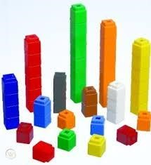

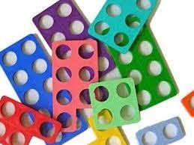
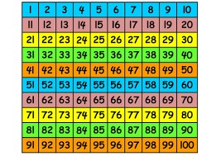
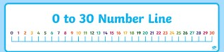
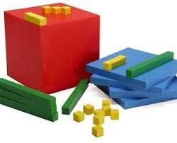
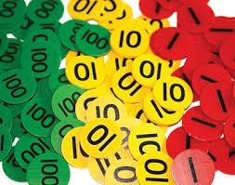

These resources will vary depending on year group and individual needs. At home, pupils very well may not have access to these school resources; however, they are just a vehicle to support a pupil’s understanding of a topic. Any objects can be used at home to replace counters, cubes etc.

Pictorial – The seeing stage
A child has sufficiently understood the hands-on experiences performed and can now relate them to representations, such as a diagram or a picture of the problem.

Abstract- The symbolic stage
A child is now capable of representing problems by using mathematical notation, for example 10 ÷ 2 = 5

Impact
Pupils will leave us prepared for the next stage in their lives with:
- Quick recall of facts and procedures
- The flexibility and fluidity to move between different contexts and representations of mathematics
- The ability to recognise relationships and make connections in mathematics
- Confidence and belief that they can achieve
- The knowledge that maths underpins most of our daily lives ● Skills and concepts that have been mastered
- Have a positive and inquisitive attitude to mathematics as an interesting and attractive subject in which all children gain success and pleasure.

A mathematical concept or skill has been mastered when a child can show it in multiple ways, using the mathematical language to explain their ideas, and can independently apply the concept to new problems in unfamiliar situations and this is the goal for our children.

Calculation Policy – Progression Step 1
Addition | Subtraction | Multiplication | Division
Children are encouraged to gain a sense of the number system through the use of counting concrete objects.  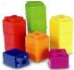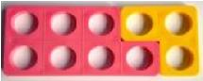  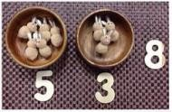  They combine objects in practical ways and count all.  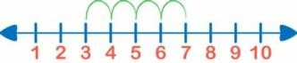  They understand addition as counting on and will count on in ones and twos using object  s, cubes, bead string and number line.  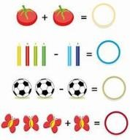  They use concrete and pictorial representation to record their calculations.  They begin to use + and = They are encouraged to develop a mental picture of the number system in their heads to use for calculations.  Higher attaining children may be able to represent their calculations using symbols and numbers within a written calculation. | Children are encouraged to gain a sense of the number system through the use of counting concrete objects.  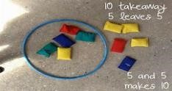  They understand subtraction as counting out.  They begin to count back in ones and twos using objects, cubes, bead string and number line.  They use concrete and pictorial representation to record their calculations.  They begin to use - and =  They are encouraged to develop a mental picture of the number system in their heads to use for calculations. Higher attaining children may be able to represent their calculations using symbols and numbers within a written calculation. | 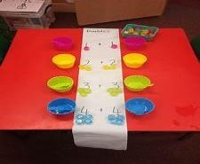  Children use concrete objects to make and count equal groups of objects.  They will count on in twos using a bead string and number line.  They understand doubling as repeated addition.  2 + 2 = 4  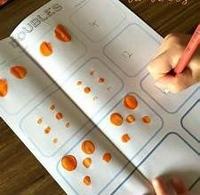  They use concrete and pictorial representation to record their calculations. Higher attaining children may be able to represent their calculations using symbols and numbers within a written calculation. | Children use concrete objects to count and share equally into 2 groups.  6 cakes shared between 2 people each person gets 3 cakes. 6 ÷2 = 3  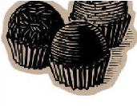  They count a set of objects and halve them by making two equal groups.  They understand sharing and halving as dividing by 2.  They will begin to use objects to make groups of 2 from a given amount.    They use concrete and pictorial representation to record their calculations.  Higher attaining children may be able to represent their calculations using symbols and numbers within a written calculation.
Calculation Policy – Addition
Objective and Strategies | Concrete | Pictorial | Abstract
Combining two parts to make a whole:  part- whole model. | 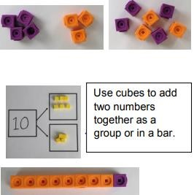 | Use jottings to represent numbers.  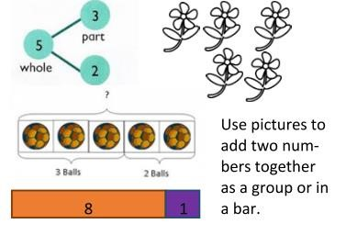 | Children will record their calculation using a pictorial method along with a calculation using numbers and symbols.  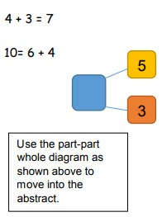  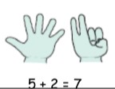  They may use their fingers to support their mental methods.
Starting at the bigger number and counting on | Start with the larger number on the bead string and count on to the smaller number to find the answer. | 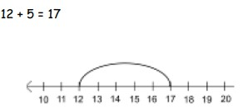  Start at the larger number on the number line | Place the larger number in your head and count on the smaller number to find your answer.  5 + 12 = 17

 | 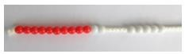 | and count on in ones or in one jump to find the answer.
Regrouping to make 10. | Start with the bigger number and use the smaller number to make 10.  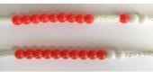  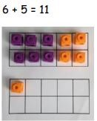 | 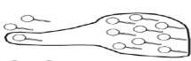  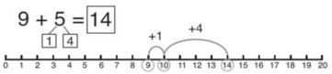  Use pictures or a number line. Regroup or partition the smaller number to make 10. | 7 + 4= 11  If I am at seven, how many more do I need to make 10?  How many more do I add on now?
Adding three single digits | 4 + 7 + 6= 17  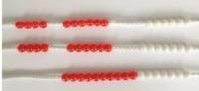  Recognise 4 and 6 together make 10. Add on 7.  Following on from making 10, make 10 with 2 of the digits (if possible) then add on the third digit. | Add together three groups of objects. Draw a picture to recombine the groups to make 10.  4 + 7 + 6 = 17  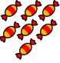  +  +  =  4 + 6 = 10 + 7 = 17  +  +  = | Combine the two numbers that make 10 and then add on the remainder.  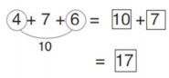

Column method - no regrouping | 24 + 15=  Add together the ones first then add the tens. Use the Base 10 blocks first before moving onto place value counters.  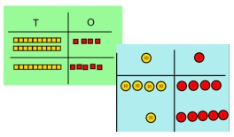 | 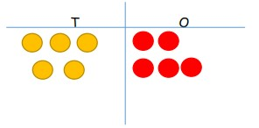  After practically using the base 10 blocks and place value counters, children can draw the counters to help them to solve additions. | 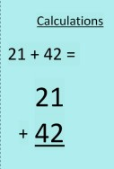

Column method - regrouping | Make both numbers on a place value grid.  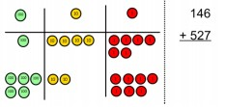  Add up the units and exchange 10 ones for one 10.  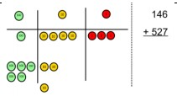  Add up the rest of the columns, exchanging the 10 counters from one column for the next place value column until every column has been added. This can also be done with Base 10 to help children clearly see that 10 ones equal 1 ten and 10 tens equal 100. As children move on to decimals, money and decimal place value counters can be used to support learning. | Children can draw a pictoral representation of the columns and place value counters to further support their learning and understanding.  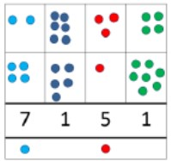 | Start by partitioning the numbers before moving on to clearly show the exchange below the addition.  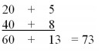  As the children move on, introduce decimals with the same number of decimal places and different. Money can be used here.  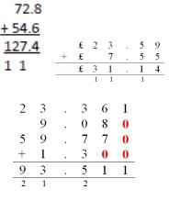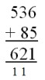

Calculation Policy – Subtraction
Objective and Strategies | Concrete | Pictorial | Abstract
Taking away ones | Use physical objects, counters, cubes etc. to show how objects can be taken away.  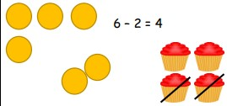   | Cross out drawn objects to show what has been taken away.  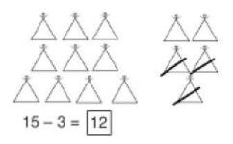 | 18 - 3 = 15  8 – 2 = 6
Counting back | Make the larger number in your subtraction. Move the beads along your bead string as you count backwards in ones.  13 – 4 =  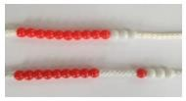  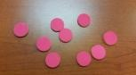  Use counters and move them away from the group as you take them away counting backwards as you go. | Count back on a number line or number track.  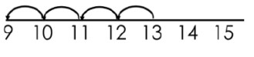  Start at the bigger number and count back the smaller number showing the jumps on the number line.  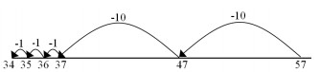  This can progress all the way to counting back using two 2 digit numbers. | Put 13 in your head, count back 4.  What number are you at?  Use your fingers to help.  13 - 4 =
Find the difference | Compare amounts and objects to find the difference.  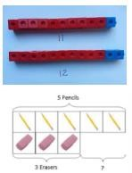  Use cubes to build towers or make bars to find the difference.  Use basic bar models with items to find the difference | Count on to find the difference.  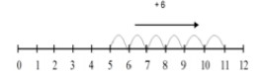  Draw bars to find the difference between 2 numbers.  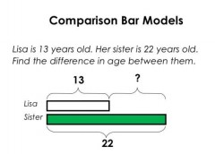 | Hannah has 23 sandwiches, Helen has 15 sandwiches.  Find the difference between the number of sandwiches.  23 - 15 =
Part Part Whole Model | Make 14 on the ten frame.  Take away the four first to make 10 and then takeaway one more so you have taken away 5. You are left with the answer of 9.  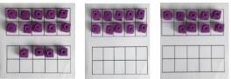  14 - 9 = | 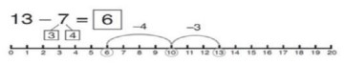  Start at 13. Take away 3 to reach 10. Then take away the remaining 4 so you have taken away 7 altogether. You have reached your answer. | How many do we take off to reach the next 10? How many do we have left to take off?  16 – 8 =

Column method - no regrouping | Use Base 10 to make the bigger number then take the smaller number away.  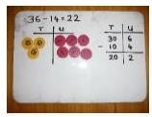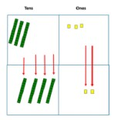  Show how you partition numbers to subtract.  Again make the larger number first. | Draw the Base 10 or place value counters alongside the written calculation to help to show working.  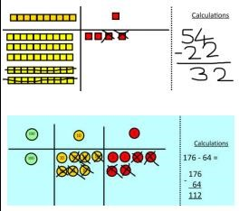 | 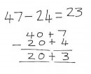  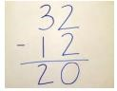  This will lead to a clear written column subtraction.
Column method  - regrouping | Use Base 10 to start with before moving on to place value counters. Start with one exchange before moving onto subtractions with 2 exchanges.  Make the larger number with the place value counters.  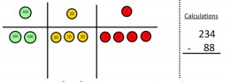  Start with the ones, can I take away 8 from 4 easily? I need to exchange one of my tens for ten ones. | 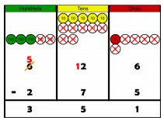  Draw the counters onto a place value grid and show what you have taken away by crossing the counters out as well as clearly showing the exchanges you make.  When confident, children can find their own way to record the exchange/regrouping. | Children can start their formal written method by partitioning the number into clear place value columns.  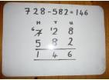  Moving forward the children use a more compact method. This will lead to an understanding of subtracting any number including decimals.

 | 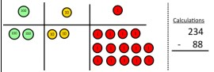  Now I can subtract my ones.  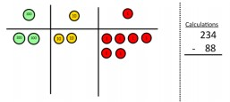  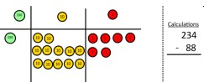  Now look at the tens, can I take away 8 tens easily? I need to exchange one hundred for ten tens.  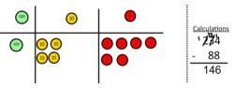  Now I can take away eight tens and complete my subtraction.  Show children how the concrete method links to the written method alongside your working. Cross out the numbers when exchanging and show where we write our new amount. | 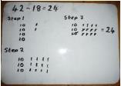  Just writing the numbers as shown here shows that the child understands the method and knows when to exchange/regroup. | 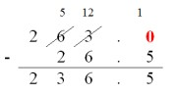
Calculation Policy – Multiplication
Objective and Strategies | Concrete | Pictorial | Abstract
Doubling | 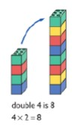  Use practical activities to show how to double a number. | Draw pictures to show how to double a number.  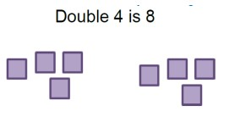 | Partition a number and then double each part before recombining it back together.  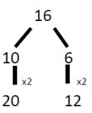
Counting in multiples | 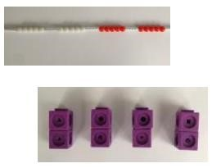  Count in multiples supported by concrete objects in equal groups. | Use a number line or pictures to continue support in counting in multiples.  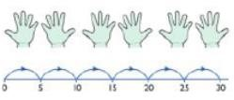 | Count in multiples of a number aloud.  Write sequences with multiples of numbers.  2, 4, 6, 8, 10  5, 10, 15, 20, 25 , 30
Repeated addition | Use different objects to add equal groups.  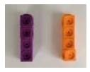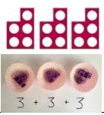 | 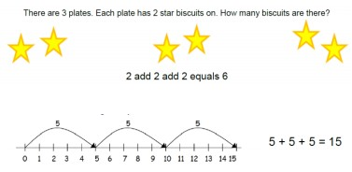 | Write addition sentences to describe objects and pictures.  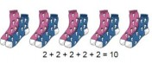

Arrays- showing commutative multiplication | Create arrays using counters/ cubes to show multiplication sentences.  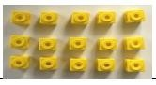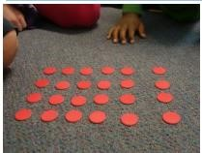 | Draw arrays in different rotations to find commutative multiplication sentences.  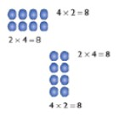  Link arrays to area of rectangles. | Use an array to write multiplication sentences and reinforce repeated addition.  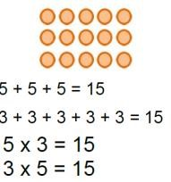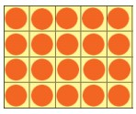
Grid Method | Show the link with arrays to first introduce the grid method.  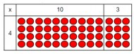  4 rows of 10  4 rows of 3  4 rows of 13  Move on to using Base 10 to move towards a more compact method. | Children can represent the work they have done with place value counters in a way that they understand. They can draw the counters, using colours to show different amounts or just use circles in the different columns to show their thinking as shown below.  24 x 3 = | Start with multiplying by one digit numbers and showing the clear addition alongside the grid.  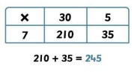  Moving forward, multiply by a 2 digit number showing the different rows within the grid method.

 | 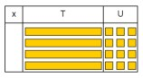  Move on to place value counters to show how we are finding groups of a number.  We are multiplying by 4 so we need 4 rows.  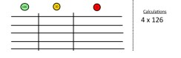  Fill each row with 126.  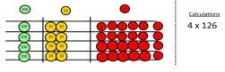  Add up each column, starting with the ones making any exchanges needed.  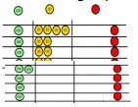  Then you have your answer. | 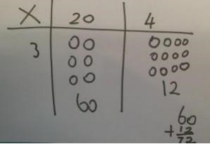 | 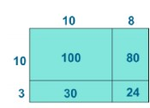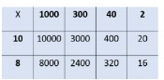
Column  multiplication | Children can continue to be supported by place value counters at the stage of multiplication.  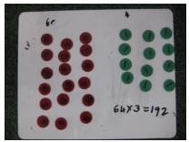  It is important at this stage that they always multiply the ones first and note down their answer followed by the tens which they note below. | Multiplication by partitioning.  Example:  42 x 8=  40 x 8 = 320  2 x 8 = 16  320 + 16 = 336 | Start with long multiplication, reminding the children about lining up their numbers clearly in columns. If it helps, children can write out what they are solving next to their answer.  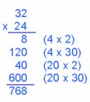  This moves to the more compact method.  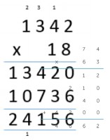

Calculation Policy – Division
Objective and Strategies | Objective and Strategies | Concrete | Pictorial
Sharing objects into groups | I have 10 cubes, can you share them equally in 2 groups?  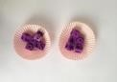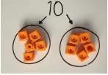 | Children use pictures or shapes to share quantities.  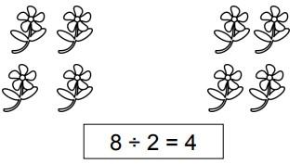 | Share 9 buns between three people.  9 ÷ 3 = 3
Division as grouping | Divide quantities into equal groups. Use cubes, counters, objects or place value counters to aid understanding.  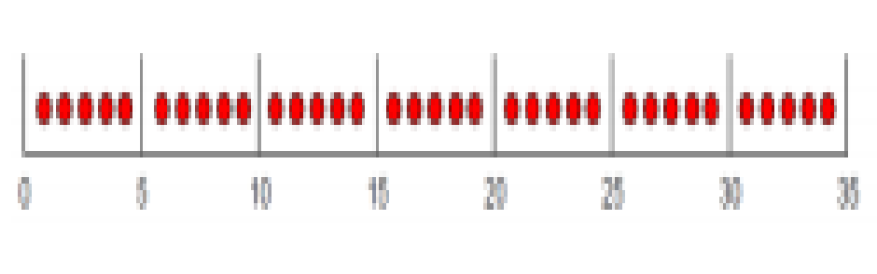  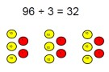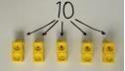   | Use a number line to show jumps in groups. The number of jumps equals the number of groups.  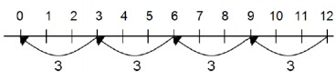  Think of the bar as a whole. Split it into the number of groups you are dividing by and work out how many would be within each group.  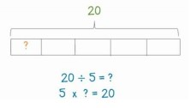 | 28 ÷ 7 = 4  Divide 28 into 7 groups. How many are in each group?

Division within arrays | Link division to multiplication by creating an array and thinking about the number sentences that can be created.  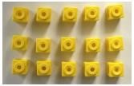  Eg.  15 ÷ 3 = 5  5 x 3 = 15  15 ÷ 5 = 3  3 x 5 = 15 | Draw an array and use lines to split the array into groups to make multiplication and division sentences.  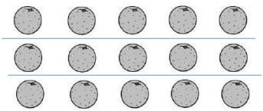 | Find the inverse of multiplication and division sentences by creating four linking number sentences.  7 x 4 = 28  4 x 7 = 28  28 ÷ 7 = 4  28 ÷ 4 = 7
Division with a  remainder | 14 ÷ 3 =  Divide objects between groups and see how much is left over.  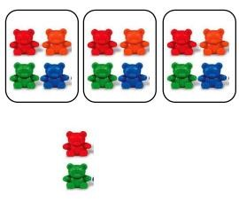 | Jump forward in equal jumps on a number line then see how many more you need to jump to find a remainder.  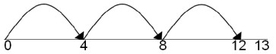  Draw dots and group them to divide an amount and clearly show a remainder.  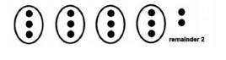 | Complete written divisions and show the remainder using r.  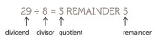

Short Division | 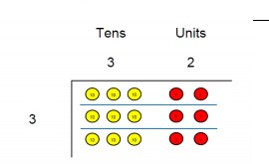  Use place value counters to divide using the bus stop method alongside.  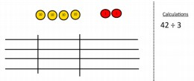  42 ÷ 3=  Start with the biggest place value, we are sharing 40 into three groups. We can put 1 ten in each group and we have 1 ten left over.  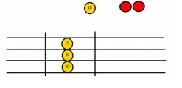  We exchange this ten for ten ones and then share the ones equally among the groups.  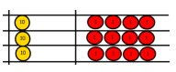  We look how much in 1 group so the answer is 14. | Students can continue to use drawn diagrams with dots or circles to help them divide numbers into equal groups.  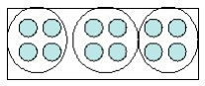  Encourage them to move towards counting in multiples to divide more efficiently. | To divide using partitioning is the next step where you partition the dividend into hundreds tens and units in this case.  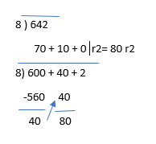  Begin with divisions that divide equally with no remainder.  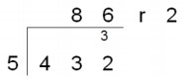  Finally move into decimal places to divide the total accurately.  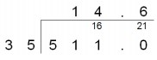
Long Division - Chunking  Method | 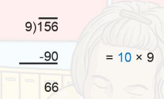 | 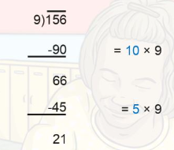 | 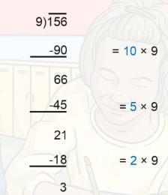  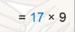

Progression step 1-4 Rules of Number
Nursery -Dosbarth Dewi Sant Reception -Dosbarth Ddraig Goch
I have explored forming a quantity in different ways, using combinations of objects or quantities.,
I can communicate how sets change when objects are added to and taken away from them.,
I have experienced grouping and sharing with objects and quantities, and I can group or share small quantities into equal-sized groups.,

Progression step 2-4 Rules of Number
Year 1 -Dosbarth Caradog Year 2 Dosbarth Branwen Year 3 -Dosbarth Gelert
I have explored additive relationships, using a range of representations. I can add and subtract whole numbers, using a variety of written and mental methods.,
I can use my understanding of multiplication to recall some multiplication facts and tables starting with tables 2, 3, 4, 5 and 10 and I can use the term ‘multiples’.,
I have explored and can use my understanding of multiplicative relationships to multiply and divide whole numbers, using a range of representations, including sharing, grouping and arrays.,

Progression step 3-4 RULES OF NUMBER
Year 4-Dosbarth Dwynwen Year 5- Dosbarth Owain Glyndwr Year 6- Dosbarth Llewelyn
I can verify calculations and statements about number by inverse reasoning and approximation methods.
I can use the four arithmetic operations confidently, efficiently and accurately with integers and decimals, and I can combine these using distributive, associative and commutative laws where appropriate.
I have extended my understanding of multiplicative reasoning to include the concept and application of ratio, proportion and scale.
I can fluently recall multiplication facts up to at least 10 x 10 and use these to derive related facts.
I have experienced and explored simple multiplicative relationships that allow me to discuss the properties of number, including factors, multiples, prime and square numbers.

