
Graphing policy
A graph is a visual representation of a relationship between, but not restricted to, two variables.
A graph generally takes the form of a one- or two-dimensional figure. Although, there are three-dimensional graphs available, they are usually considered too complex to understand easily.
A graph commonly consists of two axes called the x-axis (horizontal) and y-axis (vertical).
A graph can show Discrete or Continuous data types. Data types determines which graph to use.

Discrete:
Data that can be separated by some interval, for example:
Recording the shoe sizes of a class – Bar graph
Continuous:
When data collected is continuous, for example:
Recording temperature – Line graph

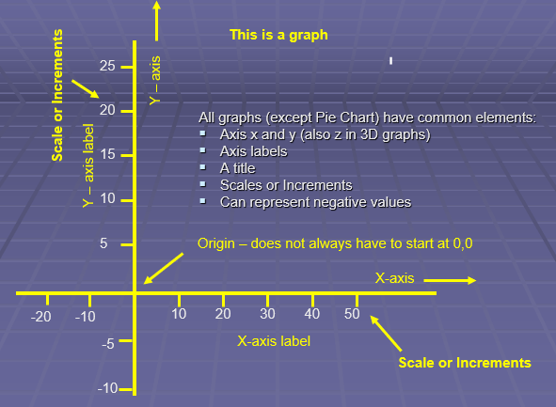
There are 5 types of graphs:-
- Pictograms
- Line
- Bar
- Pie
- Scatter

A Pictogram
A pictorial interpretation of data

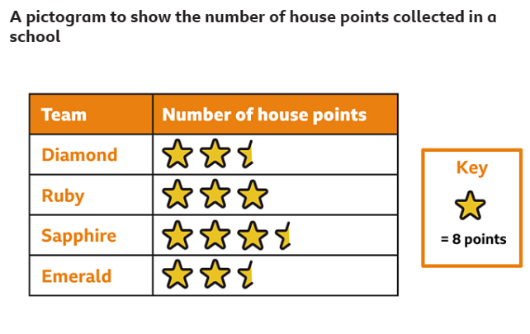

Line Graphs
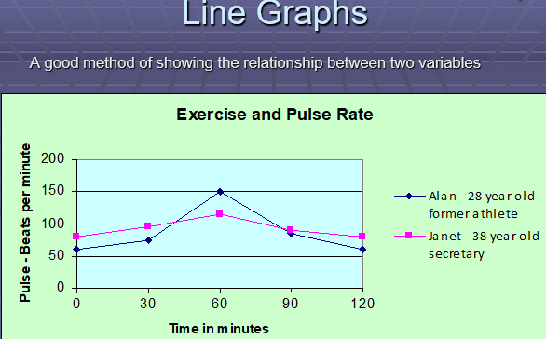

Bar Charts/Graphs
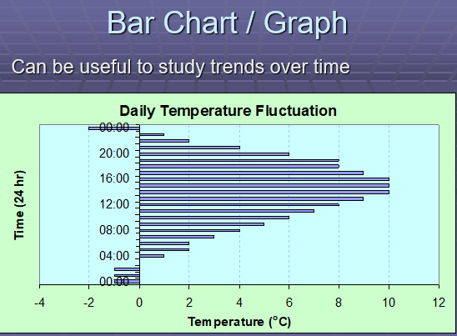

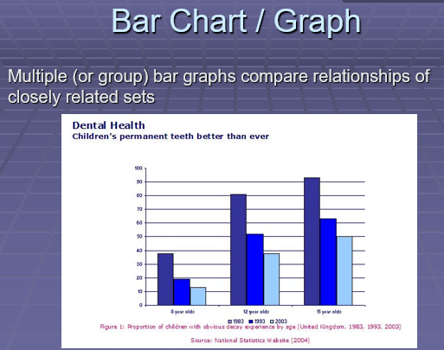

- A Pie Chart

- 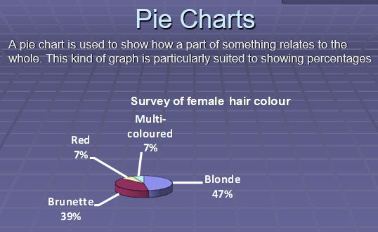

- A Scattergraph
- A scatter graph shows how much correlation there is between two variables that you suspect may be linked for instance height and weight as shown here:

- 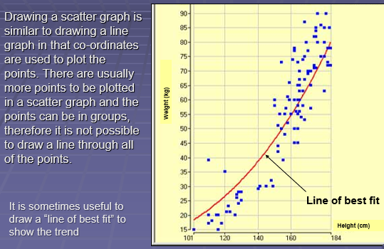

A good graph:
- Accurately shows the data
- Grabs the reader's attention
- Has a title and labels
- Is simple and uncluttered
- Clearly shows any trends or differences in the data
- Is visually accurate (i.e., if one data value is 25 and another 50, then 50 should appear to be twice the size of 25).

Creating and interpreting a Pictograms
What is a pictogram?
A pictogram is a chart that displays information about a topic. It uses pictures to show the information that has been collected.

Why do people use pictograms?
Pictograms are important because they tell you information very quickly. People use pictograms to find out information about things that are popular and common or things that people do not like. It can be easier to see information displayed in picture form rather than looking at a list of numbers.

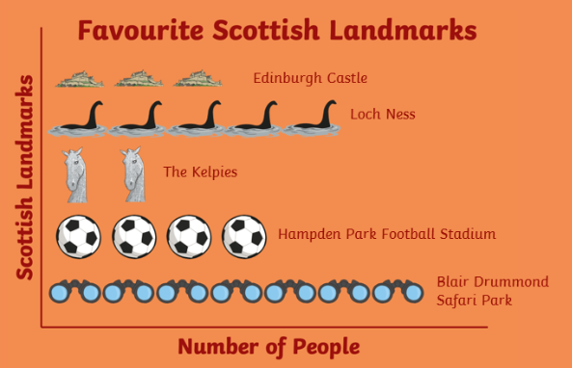
In the pictogram above each shape represents a person going to see that landmark. So:-
3 people visited Edinburgh Castle
5 people saw Loch Ness
2 people saw Kelpies
4 people went to Hampden Park
7 people went to Blair Drummond Safari Park

Sometimes pictograms have a key and pictures are cut into sections, In the pictogram below
Monday had 5 whole shapes therefore 5 x 10 =50 cars.
Tuesday had 3 and a half shapes meaning 3 x 10 + 5( for half the circle) =35
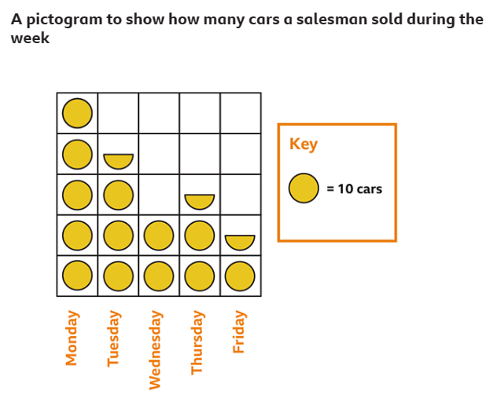
Wednesday I 2 circles meaning 2 x 10 =20 and so on.

Creating and interpreting a Bar Chart/ Graph
- Identify how many bars are needed. There are five categories here, so you need five bars. There are no negative values therefore we do not need to extend the axes
- Identify the scale you need for the other axis. Its highest value must be at least 659 and if possible, it should start at zero. If the bars are on the horizontal axis, the distance scale will be on the vertical axis.
- Draw and label the two axes. The labels are simply ‘Miles travelled’ for the vertical axis and ‘Mode of transport’ for the horizontal axis.
- Add the bars. Remember to keep the bars separate ( have an equal sized gap between each bar) and to label each one clearly, here we have placed the bars in descending order on the number of miles
- Decide on a clear title.
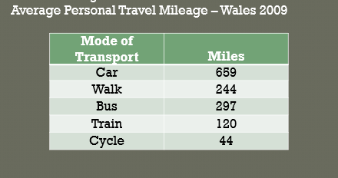
This data represents the number of personal miles travelled by the average person in Wales in 2009, and the mode of transport. Notice that the bus mileage is greater than the Walking mileage; it is not always necessary to place the categories in number order; or alphabetical order, however it may be easier to compare if the data is placed in number order, we will do this whilst drawing the graph. 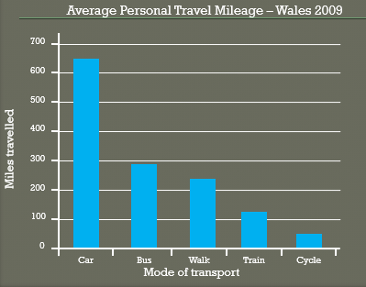
We can clearly see from the heights of the bars that cars are the most popular form of transport/

Creating and interpreting a Line Graph
Using the following data we will show how to draw a line graph.

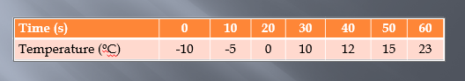
It is normal to place the variable quantity, in this case the temperature, on the y-axis.
Notice that the temperature ranges from -10 ºC to 23 ºC, this means that we will have to draw the y-axis to include negative values

As we have seen previously, we first need to draw vertical and horizontal axes, and insert the scales, in this case there are negative quantities, we therefore need to extend the y-axis below the line of the x-axis

Next we add the x and y axes labels
The first co-ordinate is at zero seconds and the temperature is -10ºC (0,-10), let’s mark it with a cross.

The second co-ordinate is( 10,-5), again we will mark it with a cross.

Now repeat for all the other data, and draw a line to connect the points

Lastly, add a title
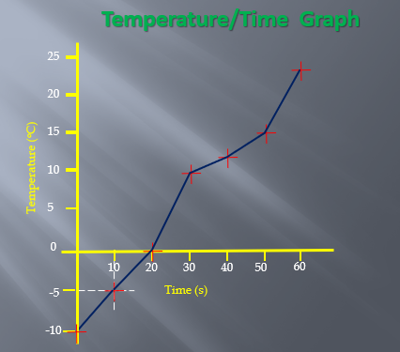

We can clearly see from this graph that as time passes the temperature rises.

Creating and interpreting a Pie Chart
A pie chart shows the share each segment has in the whole. It’s a good method of representation if you want to compare a part of a group with the whole group.
You could use a pie chart to show, say, goals scored by a team in a tournament, different types of sweets sold by a shop.
Pie charts don't give a lot of information, but they do give a quick overall impression of your results.
It is useful to add more information into pie charts by inserting figures into each segment of the chart, they are particularly good for showing percentage values.

- Decide on the total number of categories. In other words, identify the categories that you will use.
- Collect the data so the number per category can be counted (Frequency Table)

Brand Name | Tally | Frequency
Daz | |||| |||| |||| |||| |||| |||| |||| |||| | 40
Ariel | |||| |||| |||| |||| |||| |||| |||| |||| |||| |||| |||| |||| | 60
Bold | |||| |||| |||| |||| |||| |||| |||| |||| |||| |||| | 50
Fairy | |||| |||| |||| |||| |||| | 30
Other | |||| |||| |||| |||| | 20
 | TOTAL | 200

To calculate degree share, you need to divide the share that the category has by the total units and then multiply by 360 (there are 360 degrees (°) in a circle).

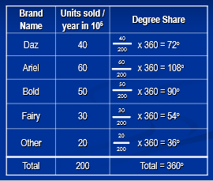

- Draw a circle using a pair of compasses
- Lightly, draw a vertical line through the centre
- With a protractor measure 72 degrees Mark this angle and draw a line from the centre to the mark
- Turn the protractor so that the zero is now on this line
- Now measure 108 degrees
- Again, turn the protractor so that zero is now on this line
- Now measure 90 degrees
- Again, turn the protractor
- And finally 54 degrees
- You should now be left with 36 degrees

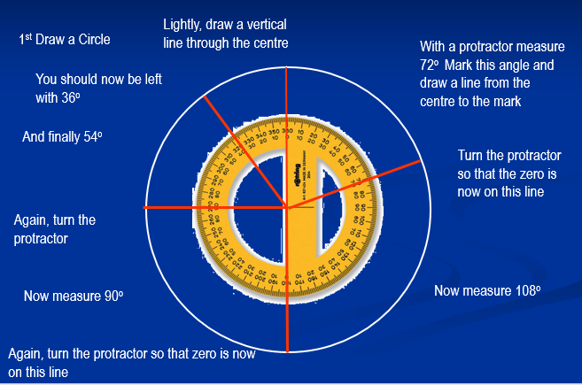

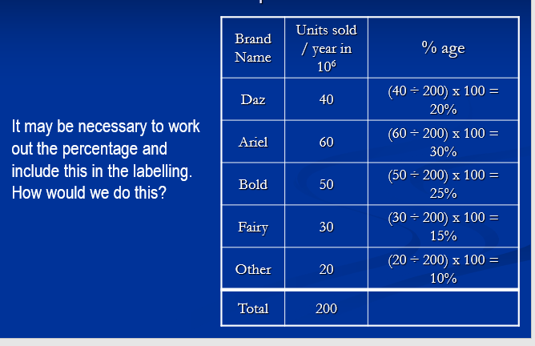

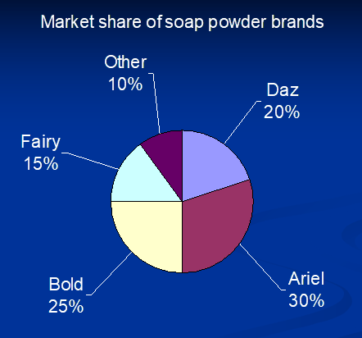

Creating and interpreting a Scattergraph
To create a scattergraph you can draw the x and y axes as you do for a line graph and then plot the data points.


