Student Health and Wellbeing Survey

Dear Parent / Guardian,

What we are doing?
Your child’s school has agreed to take part in a pilot study which involves completing a short survey run by Cardiff University about children’s health and wellbeing. Children in Key stage 2 will be invited to take part.

What is involved?
During class, your child will be asked to take part in a brief online survey, which will take about 20 minutes on average. It will ask some general questions about themselves, their feelings, what they think about school, and behaviours which can affect children’s health. These questions have been developed in consultation with teachers, parents, and children across schools in Wales. The survey will be overseen by their teachers. Children will be informed that participation is voluntary, and that if they do choose to take part, they can refuse to answer any question they do not want to. Children will be told that their answers are confidential. They won’t be asked to give their names. Our Student Health and Wellbeing Survey is taking place between September 2022 and April 2023. Some schools have been invited to take part in our survey during the Autumn wave (Sept-Dec 2022) and other schools within our Spring wave (Nov 2022 -Apr 2023). Your school will be participating in the survey in the coming weeks.

If you want a copy of the survey you can either:
- visit our website page: https://www.shrn.org.uk/student-health-and-wellbeing-survey-in-primary-schools/, or
- open your phones built-in camera, point the camera at this QR code and then tap the pop-up banner.

Who is doing the research?
The research is being undertaken by the DECIPHer research centre in Cardiff University. DECIPHer conducts research into the health and wellbeing of children and young people and is part of Cardiff University’s School of Social Sciences. The research is led by Professor Graham Moore (Deputy Director of DECIPHer) and Dr Kelly Morgan (Senior Research Fellow).

Who has funded the research?
The research has been funded by the Welsh Government.

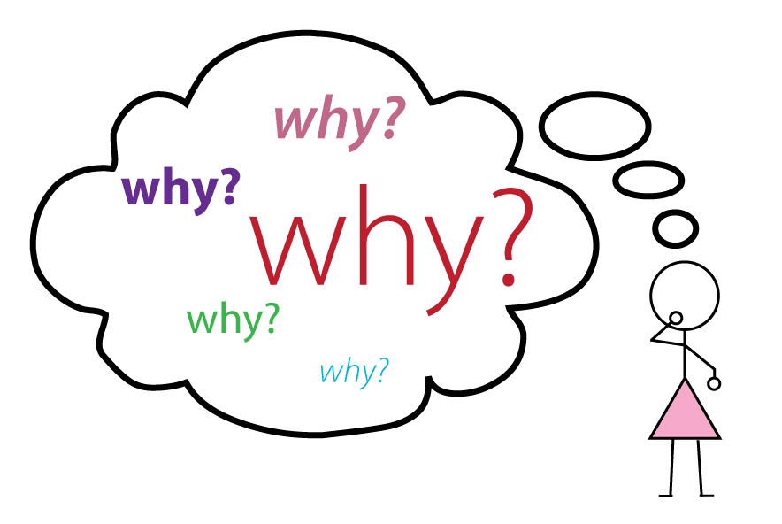
Why are we doing it?
The School Health Research Network (SHRN; http://www.shrn.org.uk/), based in DECIPHer, currently works with all secondary schools in Wales to inform and evaluate actions to improve young people’s health. It does this partly through conducting surveys every two years.

Anonymised findings are reported back to schools, local authorities and Welsh Government. The network includes events for school staff to discuss well-being topics and plan ways to improve young people’s health.
The current study aims to understand how SHRN can work with primary schools to improve health and wellbeing of younger children. This involves using a survey to measure children’s health and well-being before they move into secondary school. It also involves developing ways of working with primary schools and the secondary schools they feed into to plan and evaluate actions to improve and support health and wellbeing.
We conducted a similar survey of Year 6 primary school pupils in 2019 and in 2021 and carried out pilot work to test the survey among Key Stage 2 pupils during Spring 2022. This pilot study is being conducted to test the use of the survey with all Key stage 2 pupils. Comparing findings from this new survey to the earlier surveys will also provide important information on how the COVID-19 pandemic has affected children’s health and well-being. It will also help provide an overall picture of health and wellbeing for 7-11 year olds in Wales.

Does my child have to take part?
Although your child’s school has agreed to take part in the study, it is up to you and your child whether they take part. Please talk to your child about the study. If you agree, your child’s teacher will check whether your child is happy to take part on the day of the survey. If they choose not to take part, they will be provided with alternative activities. If you do not want your child to take part in the survey, please contact your school within the next two weeks
Can my child change their mind if they decide they want to stop taking part?
If your child does choose to take part, they can change their mind and stop completing the survey at any time. Their teachers will tell them this before the survey starts. However, once they have completed the survey, because responses are collected anonymously, we will not be able to identify an individual child’s responses to delete them.

What will happen to my child’s answers?
All answers will be anonymous. That means the research team will not know who takes part in the survey. We do not collect any identifiable information, and will not ask for your child’s name at any point. All data will be stored securely on a password-protected university server. Anonymised information will be retained indefinitely and in accordance with GDPR, because it is likely to have continuing value for research purposes, for example, to understand change over time in children’s health and wellbeing through combining with previous and subsequent anonymised surveys. Cardiff University is the data controller.
More information on Cardiff University’s data protection policies and procedures and privacy notices can be found here at https://www.cardiff.ac.uk/public-information/policies-and-procedures/data-protection. Anonymous summaries of the data will be included in reports to schools, local authorities and Welsh Government, and will be published in scientific journal articles. It may also be used by the research team, or other approved researchers, for non-commercial research purposes in the future. An anonymous dataset may be uploaded in to an archive where other university based researchers can access it for scientific research.

Has the study received ethical approval?
All research in Cardiff University is reviewed by an ethics committee who check that everything we’re planning to do is fair. This research was assessed by the Cardiff University School of Social Sciences Ethics Committee. The committee can be contacted with any queries at socsi-ethics@cardiff.ac.uk
What do I need to do now?
If you are happy for your child to take part, then you don’t need to do anything further. If you do not want your child to take part in the survey, please contact your school within the next two weeks, who will make arrangements to ensure that your child does not take part and is discreetly given alternative activities to complete while their class complete the survey.
If you have any further questions about the study, please get in touch with our research team on PrimarySHRN@cardiff.ac.uk

